Dependency Injection: is a coding pattern in which a class receives its dependencies from external sources rather than creating them itself.

**Dependency injection** (DI) is an important application design pattern. **Angular** has its own DI framework, which is typically used in the design of **Angular** applications to increase their efficiency and modularity. **Dependencies** are services or objects that a class needs to perform its function.

What is InjectionToken?

**InjectionToken** is parameterized on T which is the type of object which will be returned by the Injector .

DI using normal class

export class AuthenticationService {

constructor( @Inject(HttpClient) private _http: HttpClient) {

}

-------------------------------------------

export class LoginComponent implements OnInit {

loginForm: FormGroup;

ErrMessage: string = null;

constructor(

private formBuilder: FormBuilder,

@Inject(AuthenticationService) protected http: AuthenticationService,

private router: Router) {

this.formInit();

}

# Injection Token

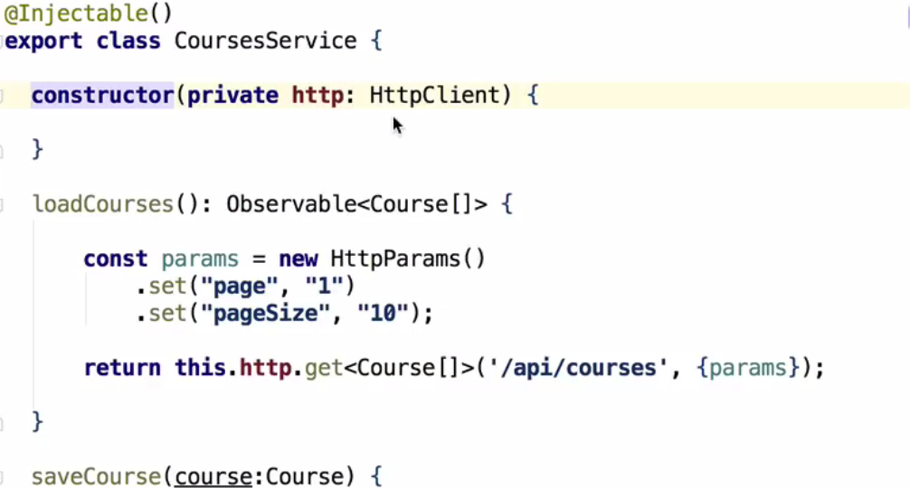

Injection token token is what uniquely identify the dependency, each dependency have unique injection token.

